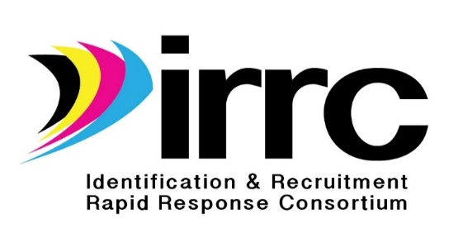
IRRC Materials Equity Review Procedures

Definition: The IRRC equity review is designed to ensure that all forms, materials, assessments, and other products developed through IRRC are fair, impartial, and equitable for all users regardless of race, gender, national origin, age, language, religion, and individuals with a disability.

Purpose: The purpose of the IRRC materials equity procedures is to use an equity process to review all materials produced through the Consortium Incentive Grant to ensure their equitability as specified in the definition above.

Criteria: The Equity Review Tool has been developed after consulting with the Equity Assistance Center (EAC) network and has been adapted by the IRRC Technical Support Team. This tool contains specific criteria for ensuring fairness of language, layout, and design of materials with respect to race, gender, national origin, language, age, religion, and individuals with a disability.

Procedures: A panel of migrant educators/administrators with knowledge and experience in working with and/or administering MEP programs will review all materials developed by the project.

The panel will review each IRRC product using the equity review procedures to determine fidelity to the established criteria. The IRRC Director will be notified if any product fails to meet one or more of the equity standards. Necessary revisions will be made by the IRRC Director with assistance from selected members of the project’s Technical Support Team within four weeks after the panel has completed their review. The revised product will be posted on the IRR website at www.idr-consortium.net

Comments: Anyone who would like to comment on the IRRC Materials Equity Review process or the materials and products produced by the project should contact the director: Michael Maye, Fort Scott Community College, 2108 S. Horton St., Fort Scott, KS 66701; phone: (845) 588-5115; email: mmaye2929@gmail.com

